

**Street Manager**

Accepting/Disputing an Inspection

**Version 1.0**

**February 2023**

**Promoter**

**Journey**



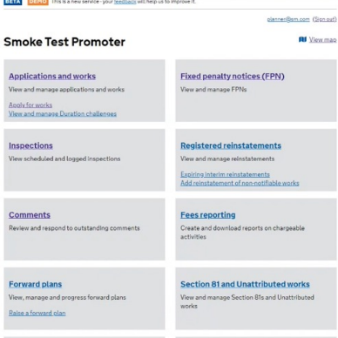

Click on the Inspections list page on the home screen.

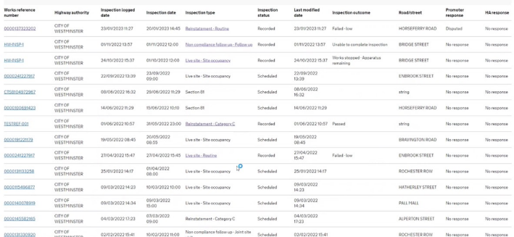

Select the inspection you

want to respond to.



Once you have opened the 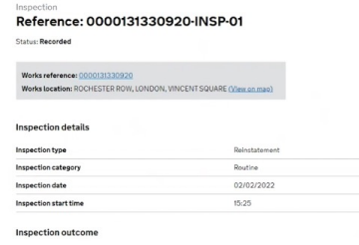

inspection, scroll to the bottom 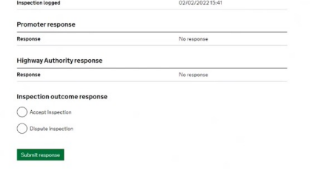

of the page and you will see

the section for promoter and

highway authority responses.



Select the option to either accept 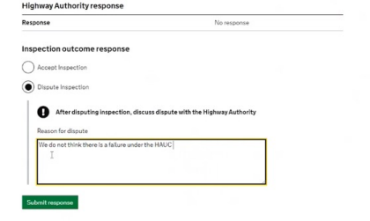

or dispute the inspection. If you

select ‘dispute inspection’, a

dialogue box will open to allow 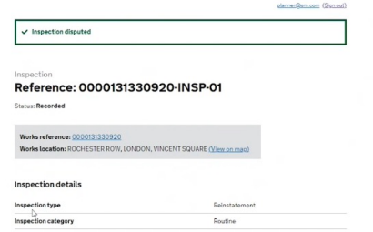

you to enter your reasons for

disputing the inspection. Once

you have submitted your

response, a confirmation

message will appear at the top of

the page.



If you return to the 

Inspections list page you

will see promoter response

and HA response filters.

You can filter these to

show only accepted or

disputed inspections.

Simply select the relevant

option and then click ‘apply

filters’.



**Highway Authority**

**Journey**



Click on the inspections list 

page and select an

inspection to review.



If the promoter accepts the 

inspection, but hasn't recorded

it on Street Manager, you can

enter the outcome at the bottom

of the inspection page. (This

option is only available on a

failure that a promoter has 

previously disputed).



You must enter the reasons for

accepting before you submit the

response.



When you return to the 

The HA should only use this function in circumstances

where they have spoken to the promoter and the failure has been agreed.



inspections list page you will be able to see the updated HA response.